Atonement Lutheran Church
6281 West Yale Ave; Lakewood, Colorado 80227
Church Office: 303.985.1122; churchoffice@atonement-denver.org
Website: www.Atonementdenver.org
Pastor Kristi Beebe: 303-246-6995 (Cell); Ministers: All Members & Visitors!

“Living in God’s Love ~ Reaching Out with Hope”

Christ the King Sunday

November 22nd, 2020
10:00 AM Worship

Tune into FM 89.5 to hear Service from your car radio

ANNOUNCEMENTS / PRAYER CONCERNS

CONFESSION AND FORGIVENESS

Blessed be the holy Trinity, ☩ one God,
in whose image we are made,
who claims us and calls us beloved.
Amen.

Holy One,
we confess that we are not always awake
for your guidance and direction.
We are not always faithful in using the
gifts you have bestowed upon us.
We can often forget the least of our brothers
and sisters both here and around the globe,
and do not always see your beautiful image
in one another.
Take away the sin that enters our lives and
divides your beloved community.
Open our hearts to your coming,
open our eyes to see you in our neighbor,
open our hands to serve your creation.
Amen.

Beloved, we are God’s children,
and Jesus, our Beloved, opens the door to us.
Through ☩ Jesus you are forgiven,
by Jesus you are welcome,
in Jesus you are called to rejoice!
Let us live in the promises prepared for us
from the foundation of the world.
Amen.

GATHERING SONG: Crown Him with Many Crowns ELW #855

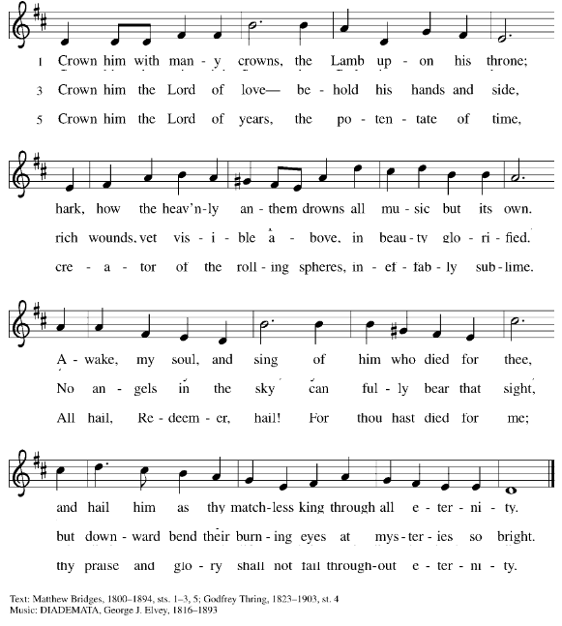

APOSTOLIC GREETING

P: The grace of our Lord Jesus Christ, the love of God, and the communion of the Holy Spirit be with you all.
C: And also with you.

PRAYER OF THE DAY

GOSPEL ACCLAMATION: Celtic Alleluia ELW #174

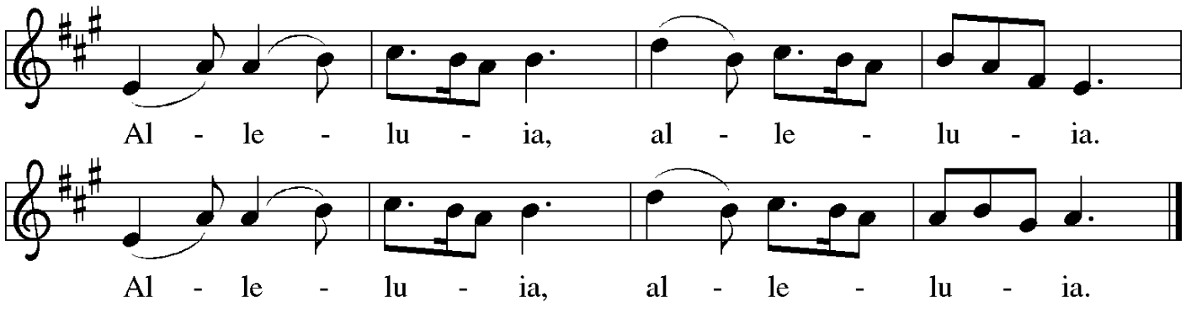

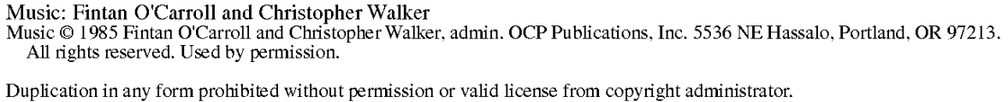

GOSPEL ANNOUNCEMENT
P: The Holy Gospel according to Matthew the 25th chapter, verses 31-46
C: Glory to you, O Lord.
Following the reading:
P: The Gospel of our Lord . . . C: Praise to you, O Christ.

A TIME WITH OUR YOUNG PEOPLE
SERMON
SPECIAL MUSIC:
There is a Redeemer Melody Green
APOSTLES’ CREED:
I believe in God, the Father almighty,
creator of heaven and earth.
I believe in Jesus Christ, God’s only Son, our Lord,
who was conceived by the Holy Spirit,
born of the virgin Mary,
suffered under Pontius Pilate,
was crucified, died, and was buried;
he descended to the dead.*
On the third day he rose again;
he ascended into heaven,
he is seated at the right hand of the Father,
and he will come to judge the living and the dead.
I believe in the Holy Spirit,
the holy catholic church,
the communion of saints,
the forgiveness of sins,
the resurrection of the body,
and the life everlasting. Amen.

PRAYERS OF THE CHURCH

After each prayer petition:
AM: Hear us, O God C: Your mercy is great.

OFFERING OF OUR GIFTS, TITHES & MUSIC: Offering will be
collected at the entrance/exit of the parking lot. Giving may be via
postal mail, online through the website, or texted to: # 720-513-1562. Thank you! Your monetary gifts are very much needed and appreciated.

OFFERTORY PRAYER
God of all goodness, generations have turned to you, gathered around your table, and shared your abundant blessings. Number us among them that, as we gather these gifts from your abundance,
and give thanks for your rich blessings, we may feast upon your
very self and care for all that you have made, through Jesus Christ, our Sovereign and Servant.
Amen.

THE WORDS OF INSTITUTION

THE LORD’S PRAYER
P: Gathered into one by the Holy Spirit, let us pray as Jesus taught us:
C: Our Father in heaven, hallowed be your name, your kingdom come, your will be done, on earth as in heaven. Give us today our daily bread. Forgive us our sins as we forgive those who sin against us. Save us from the time of trial and deliver us from evil. For the kingdom, the power, and the glory are yours, now and forever. Amen.

SHARING OF HOLY COMMUNION

POST-COMMUNION BLESSING
P: And now may the body and blood of our Lord Jesus Christ
strengthen you and keep you always in his grace
C: Amen.

PRAYER AFTER COMMUNION

P: Lord Jesus, in this simple meal you have set a banquet. Sustain us on the journey, strengthen us to care for the least of your beloved children, and give us glad and generous hearts as we meet you on the way.

C: Amen.

BENEDICTION

SENDING SONG: Victory Chant Joseph Vogels

Verse 1
Hail Jesus You're my King (ECHO)
Your life frees me to sing (ECHO)
I will praise You all my days (ECHO)
You're perfect in all Your ways (ECHO)

Verse 2
Hail Jesus You're my Lord (ECHO)
I will obey Your word (ECHO)
I want to see Your kingdom come (ECHO)
Not my will but Yours be done (ECHO)

Verse 3
Glory glory to the Lamb (ECHO)
You take me into the land (ECHO)
We will conquer in Your name (ECHO)
And proclaim that Jesus reigns (ECHO)

Verse 1 (repeat)
Hail Jesus You're my King (ECHO)
Your life frees me to sing (ECHO)
I will praise You all my days (ECHO)
You're perfect in all Your ways (ECHO)

Ending
How wonderful You are!

DISMISSAL

AM: Beloved of God, go in peace to love and serve the Lord.
C: Thanks be to God!

From Sundays and Seasons.com. Copyright 2018 Augsburg Fortress.
All rights reserved. Reprinted by permission under Augsburg Fortress Liturgies Annual License.

Lectionary Readings for Today

FIRST READING: Ezekiel 34:11-16, 20-24 (read at home)
PSALM: Psalm 95:1-7a (to be read at home)
SECOND READING: Ephesians 1:15-23 (read at home)
GOSPEL: Matthew 25:31-46 (read at service)

Stewardship Snippet: “And the king will answer them, ‘Truly I tell you, just as you did it to one of the least of these who are members of my family, you did it to me.’”– Matthew 25:40
When our thankfulness translates into action and service to “the least of these,” we may never fully realize the ripple effects. How might
you show gratitude to God in tangible ways that lift up your
neighbor in need?

FIA Gratitude Quote
“In ordinary life, we hardly realize that we receive a great deal more than we give, and that it is only with gratitude that life becomes rich.”
-Dietrich Bonhoeffer

This Week in Our Prayers
Recent

Adam, The Blair Family, Jim Bland, Katy Brackeen, Bridget Thompson, Audrey Clausen, Tracy Ford, Todd Gilbert, Grace Gilette, Doug Hepler,
Jane Hoeft, Jason, Lizzie Koch, Laura Lewellen, Danielle and Jaime Lewis, Linda Hupala, Ken McGrahahan, Steve Midthun, Jodi Paynter,
Mary Pohlemus, Kim Reed, Susan Routzahn, Aimee Rupprecht,
Marjorie, Carl and Denine Sandoval, Mike Skaff, Shelly Slinkard,
Beth Thompson, and the family and friends of Dewaine Silker.
Ongoing
Annette Brackeen, Evangie Conklin, Leslie Crowe, Olivia Estep, Oscar Otto, Charlotte Pienkos, Craig Poore, Jason Robinson, Lisa S.

*Special prayers for those struggling with decisions regarding Thanksgiving plans with family and friends in light of Covid-19 restrictions and recommendations.

DROP IN THE BUCKET Benevolence
for November goes to:
Rainbow Trail Lutheran Camp

Please give generously to this wonderful ministry.

The holidays are just around the corner!
Don’t forget Shop with Scrip
Go to www.shopwithscrip.com
Sign up for gift cards from over 780 retailers
Rebates from 2-16% given directly to Atonement
every time you shop

Monthly Food Donations Community Ministry has asked us to donate Jell-O, Jelly, Cake Mix, and Soup to their pantry this month. You may drop off food at the office, or drop off food in the shopping cart outside during Sunday worship.

Virtual
Wednesday November 25th at 7:00 PM
Service will include all churches in the South Metro Conference.
Of course, Pastor Kristi will be participating.
Zoom link is in our email blast!

Faith in Action News

   Happy Thanksgiving!
When we reflect on things that we are grateful for, it can bring us peace.
The Faith In Action Team has hosted The Global Gift Fair for the past 15 years
to help out some special non-profits; some local, some in different countries. This year, due to COVID-19 restrictions, we are promoting these organizations virtually. Please consider supporting your favorite cause by ordering on-line. You’ll need to cut and paste the website into your browser in order to place an order. There is also a link to the flyer in the email blast. (Note that Global Mamas offers a discount when you enter ATONEMENT as a code. This is because the products are cheaper when you purchase them in person.)
As you peruse the attached brochure, use your imagination and pretend that you are strolling around the market appreciating these incredible organizations, hopeful stories, unique goods and the talented artisans who created them. Shopping for a cause…what FUN!
Blessings,
The Faith In Action Team
P.S. The proceeds from our bake sale always go to Lutheran World Hunger.

New Beginning Worship Service at the Women’s Correctional Facility: Now you can join Pastor Terry and the New Beginnings Community virtually! Friday night worship is: https://www.newbeginningswc.org/, look for the worship button.

Colorado Gives Day is Dec. 8th, 2020 Join thousands of
Coloradans to support local nonprofits on Tuesday, December 8th. The $1 Million Incentive Fund made possible by Community First Foundation, FirstBank
and other community members boosts the value of every donation.
You can go to ColoradoGives.org to investigate the Non-Profits that you
wish to support. This is a neat way to donate because on this particular day, your donations are “matched” (increased).

Welcome to Atonement Lutheran Church
Lawn Chair/Parking Lot Worship

For every one’s safety, please remember:

Remember Atonement Online Gatherings:
- Tuesdays at 7:00 pm - Pastor’s Bible Study via Facebook
Wild Women of the Bible (50th Ordination of Women in the Ministry!)
- Wednesdays at 5:00 pm - Children’s Story Time --
via Facebook
- Wednesdays at 11:30am - Music Time – Join Kari Bland and Carol Ott for a musical good time!

All Gatherings and Worship are posted on the Atonement’s Facebook page and our website: www. AtonementDenver.org for viewing at
another time. For detailed instructions on accessing the online
Gatherings and Worship check the website,
or call the office: 303.985.1122

